Manvel High School and Dawson High School

2nd Invitational Track Meet
HELD AT MANVEL HIGH SCHOOL: 19601 TX-6, MANVEL, TX 77578

The Booster Club, Coaches, Girls and Boys Track Teams
of Manvel and Dawson High School
would like to invite your team to the
2020 Manvel-Dawson Invitational on Friday, February 21, 2020

General Information:
- UIL rules will govern eligibility and participation. Scoring will be done using the Old National Federation scoring method of 6 places: 10-8-6-4-2-1 for individual events and 20-16-12-8-4-2 for relay events.
- There will be a $150 entry fee for each team or $300 for both teams (boys and girls). Make checks payable to Manvel High School Booster Club-Manvel/Dawson Invitational.
Please return entry fees to Attn: Jones/Bennett/Myers at 19601 TX-6, Manvel, Texas 77578. The entry fee is
$150 or $300 for both teams (boys and girls).
- Starting blocks will be furnished.
- Only ¼” spikes or smaller will be allowed on the track and runways.
- The long jump and triple jump will have 4 jumps and the horizontal jumps will have minimum marks
Girls Long – 15’0 Girls Triple – 32’0
Boys Long – 18’0 Boys Triple – 41’0
- Throwers will have 4 throws; minimum marks for the throws are
Girls Shot Put – 28’0 Girls Discus – 85’0
Boys Shot Put – 40’0 Boys Discus – 110’0
- NO ADHESIVE TAPE WILL BE ALLOWED ON THE TRACK OR RUNWAY.
- The girl’s high jump will start at 4’4”, boys high jump will start at 5’4”
- The girl’s pole vault will start at TBA, boys pole vault will start at TBA. (coaches can vote)
- Awards will be given to the Team Champion and Runner-Up Team. Individual medals will be given to the first 3 places.
- The Manvel/Dawson Track Teams will provide a meal and cold drink to all officials and coaches of attending schools.
- All school busses are to be parked on the east corner of the stadium closest to softball field.
- The Scratch Meeting will begin at 1:00 PM in the War Room of Manvel High School.
(enter through double doors-South end of track-opposite of score board)
- If you plan to attend please contact Coach Dianna Jones at dwjones@alvinisd.net;
Coach Greg Bennett at gbennett@alvinisd.net
Coach Troy Myers at MyersT@pearlandisd.org

DAWSON HIGH SCHOOL CONTACT
Troy Myers (Girls and Boys)
Head Track & Field Coach

Coach Myers - 713-419-5949
email: MyersT@pearlandisd.org

MANVEL HIGH SCHOOL CONTACT
Dianna Jones (Girls) and Greg Bennett (Boys)
Head Track & Field Coaches
Coach Jones- 830-237-4012
email: dwjones@alvinisd.net
Coach Bennett – 281-245-2232
email: gbennett@alvinisd.net

2020 Manvel/Dawson High School Invitational

1:00 PM Coaches Scratch Meeting
(enter through double doors-South end of track-opposite of score board

2:00 PM Field Events

- Girl and Boy Field Events will run simultaneously
- Girl Field Events will be held at Manvel Junior High (Adjacent to Manvel HS)
(Except TJ will be @ MHS pits: upon conclusion of boys LJ)
(Except PV will be @ MHS Girls/Boys)
(Shot-Put and Discus will be in reserve order. This will allow dual participant’s time to check in and throw).

- Boy Field Events will be held at Manvel High School
(Shot-Put and Discus will be in reserve order. This will allow dual participant’s time to check in and throw).

Triple Jump: (Boys @ MHS /Girls @ MHS adjacent to MHS Field)
- Pit 1 (closest to Tennis Courts: Girls TJ)
- Pit 2 (closest to Track: Boys TJ)
Long Jump: (Boys @ MHS /Girls @ MJH adjacent to MHS Field)
Shot Put: (Boys @ MHS /Girls @ MJH adjacent to MHS Field)
Discus: (Boys @ MHS /Girls @ MJH adjacent to MHS Field)
High Jump: (Boys @ MHS /Girls @ MJH adjacent to MHS Field)
Pole Vault: (Girls/Boys @ MHS)

1:30-3:00 PM Coaches Meal
- Coaches Meal hosted in the War Room @ MHS
(enter through double doors-South end of track-opposite of score board)

2:30-PM Parent RELAY- 4 x 100m-$25 per team-Pay fee at start line

3:00 PM- 3200M RUN
- Running Finals for time
- Rolling Schedule
- All Finals- Girls followed by Boys

3:30 PM- RUNNING FINALS FOR TIME (or 30 minutes after conclusion of field events)
- Running Finals for time
- Rolling Schedule
- All Finals- Girls followed by Boys

400 relay
800 meter run
100 hurdles
110 hurdles
100 meter dash
4 x 100m Soarin’ Hoka Hey Relay
800 meter relay
400 meter dash
300 meter hurdles
200 meter dash
1600 meter run
1600 meter relay

TEAM CHAMPION AWARDS PRESENTATION

TIMING:
Johnny Washington- Entries will be through Direct Athletics: https://www.directathletics.com/

COACHES MEAL COUNT:
At check-in, we will have meal tickets for your coaches. Please let me know how many you will need?
The meal will be catered in by Honore’s Cajun Café, in the War Room (where coaches meeting/check in is located)

STUDENT MEAL DEAL:
Honore’s Cajun Café is offering meal deal (see flyer attached) and delivery to coaches for their athletes. Please see attached flyer “meal deal”. They will have it ready, at time of check in if you pre-order. Please let me know.

MILESPLIT:
Milesplit will be on site showcasing your athletes.

BSN SPORTS:
Leah Winfield will be on site/check-in giving away goodies
lwinfield@bsnsports.com
832-385-8862

KONA ICE:
Will be on site selling ice “COLD” snow cones

ELEVATE NUTRITION:
Will be on site giving away and selling goodies.

HONORE’S CAJUN FOOD TRUCK:
Will be on site selling delicious Cajun Food

SPECTATOR ENTRANCE FEE:
There will be a charge to the general public for meet entrance. Adult Ticket-$5 Students-$3. Please let your parents know, and also to bring lawn chairs.

ENTRIES:
Entries are due on Wednesday, February 19^{th,} 2020 at midnight (12 p.m.). On Friday, at the coaches meeting you will only be able to scratch athletes (ONLY) from events

SCRATCH MEETING:
Scratch meeting will be held in the War Room. Located in the double glass doors, South end of football field. (Enter through double glass doors-South end of track-opposite of score board.

HOUSEKEEPING:
Please help monitor your athletes throughout the meet by making sure they are keeping their team camp area clean during and after the meet. We will have plenty of trash cans around the facility for everyone to use.
- Each coach will receive a trash bag at the scratch meeting for team camp area.
- Please pick-up your packet on the South side of the field.
- Please no food, gum, sunflower seeds allowed in the warm up area (turf field). You will be
asked to go sit in the stands.
- Please keep all athletes off of the high jump pit and pole vault pit as this seems to be the best
area for naps during the running events.
- Please no spectators, coaches, athletes allowed to hangout or make camp inside the perimeter
of the football field (turf area).
- Any athlete found inside Manvel High School or Manvel Junior High School will be disqualified. NO EXCEPTIONS!!!

PERTINENT INFORMATION BELOW
- Bus parking
- Map of area
- Team camp area (restrooms available)
- Concession Stand(s) Baseball area
- Field event area Boys and Girls
- Trainers station at finish line
- Spectator parking (Adult tickets $5 Student tickets $3)
- How to access field events from team camp area
- How to access the track from team camp area
- Restrooms
- Warm-up areas/Staging Area
- Manvel JH facilities
- Please let your parents know, and to bring lawn chairs
- Meal Deal
- Taxpayer ID Number for your business office

BUS PARKING/MAP
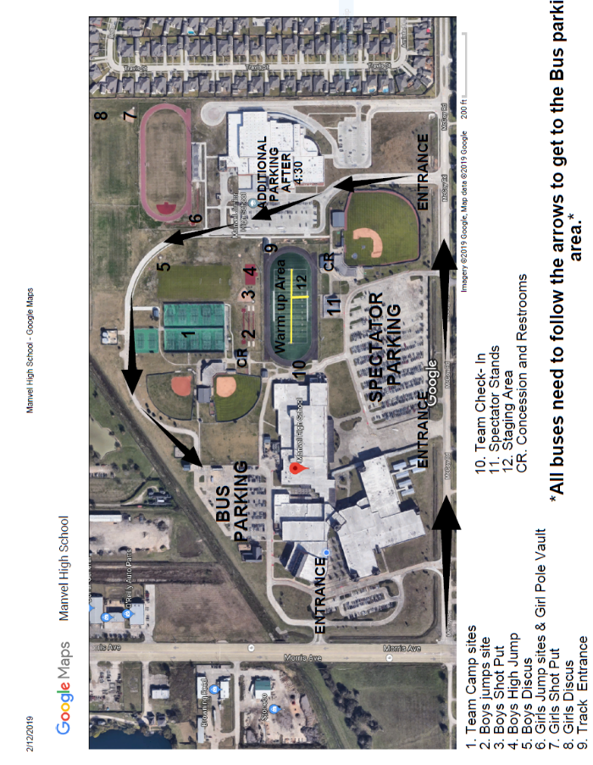

MEAL DEAL
Print for each athlete
Make Checks Payable to Manvel HS Booster Club

MEAL DEAL WILL BE DELIVERED TO MANVEL HIGH SCHOOL WITH ATHLETES NAME ON THE BOX!
COACHES CAN PICK-UP AT SCRATCH MEETING @ 1:PM IN THE WAR ROOM

SCHOOL:___________________________________________________________
PRINT PLEASE

ATHLETE NAME: _____________________________________________________
PRINT PLEASE

CHOOSE FROM HAM OR TURKEY SANDWICH
ON SOUR DOUGH BREAD, WITH CHIPS, FRESH FRUIT, LETTUCE, TOMATOES, PICKLE ON THE SIDE AND SPORT DRINK

$10 MEAL DEAL $10

19430 Highway 6, Manvel, TX 77578
281-489-7777

HAM TURKEY
MEALS WILL BE DELIVERED TO MANVEL HIGH SCHOOL IN THE WAR ROOM.
COACHES CAN PICK-UP AT SCRATCH MEETING
TAXPAYER ID NUMBER AND CERTIFICATION
